File Handling

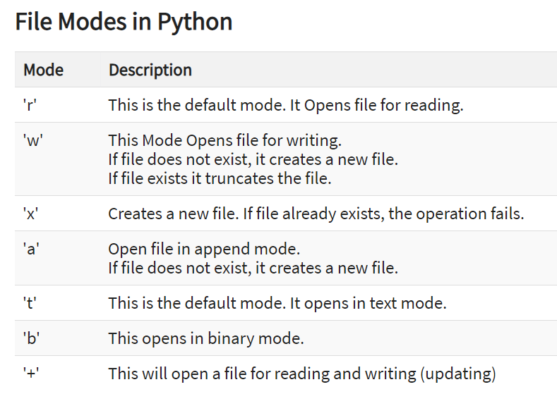

f= open("guru99.txt","w+")
#f=open("guru99.txt","a+")
for i in range(10):
f.write("This is line %d\r\n" % (i+1))
f.close()

#Open the file back and read the contents
#f=open("guru99.txt", "r")
# if f.mode == 'r':
# contents =f.read()
# print contents

#or, readlines reads the individual line into a list
#fl =f.readlines()
#for x in fl:
#print x

We don't need to explicitly call the close() method. It is done internally.
- with open("test.txt",'w',encoding = 'utf-8') as f:
- f.write("my first file\n")
- f.write("This file\n\n")
- f.write("contains three lines\n")

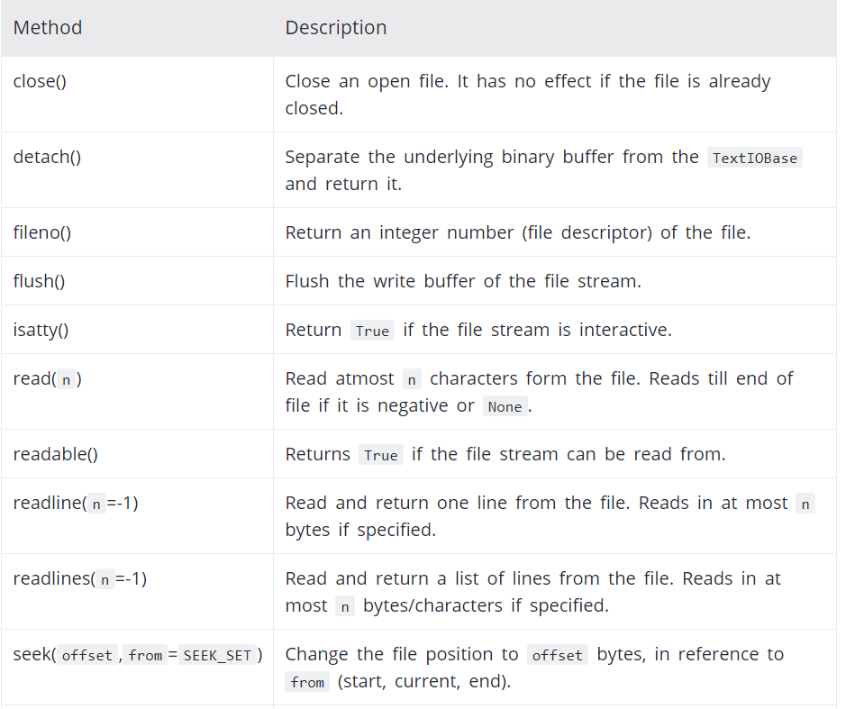

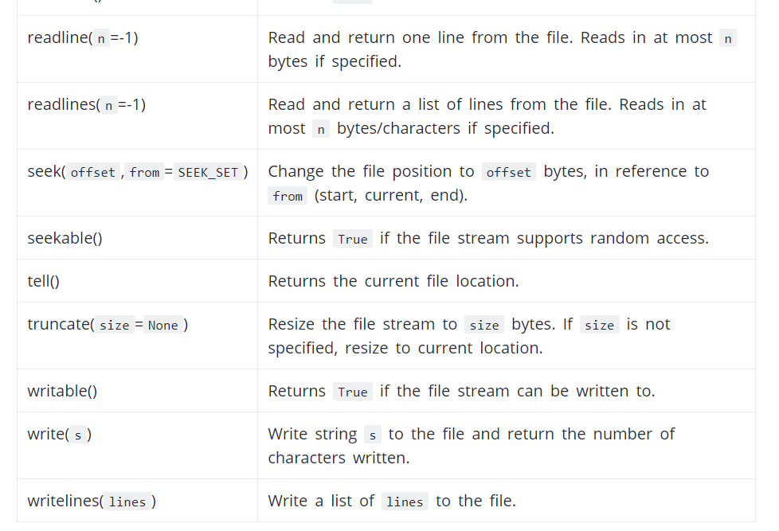

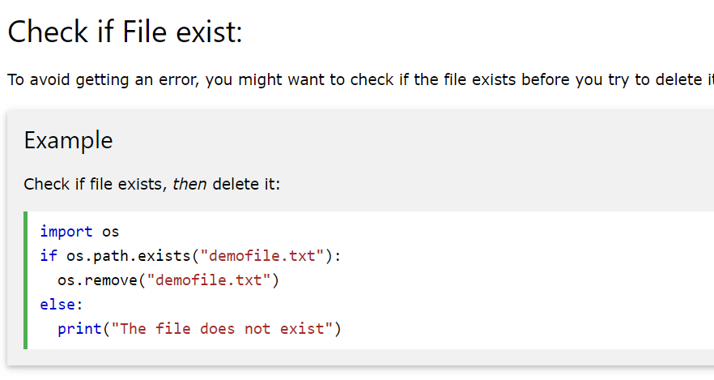

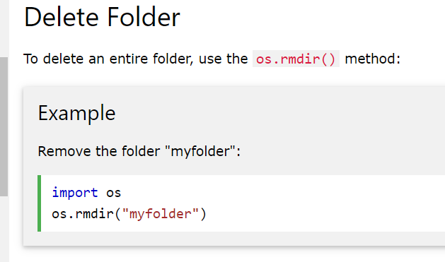

Get current Directory
The extra backslash implies escape sequence. The print() function will render this properly.
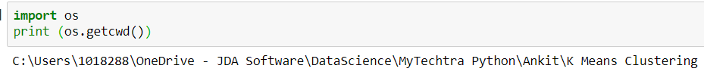

Changing Directory

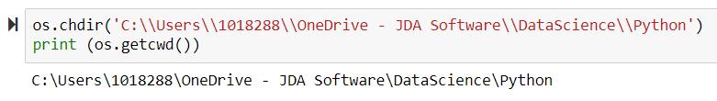

List Directories and Files
listdir() will list all folders and files inside the current directory or any specified directory

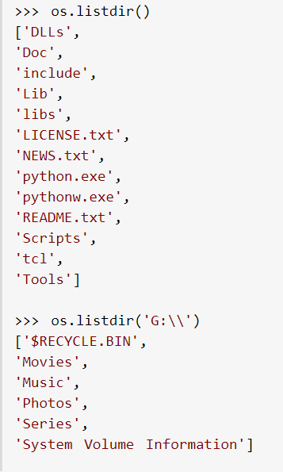

Making a New Directory
We can make a new directory using the mkdir() method.
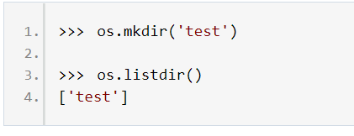

Renaming a Directory or a File
The rename() method can rename a directory or a file.

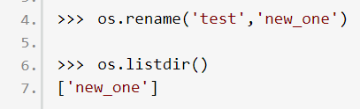

Removing Directory or File
A file can be removed (deleted) using the remove() method.
Similarly, the rmdir() method removes an empty directory.

However, note that rmdir() method can only remove empty directories.
In order to remove a non-empty directory we can use the rmtree() method inside the shutil module.

